Fama-French 5-Factor Model Analysis
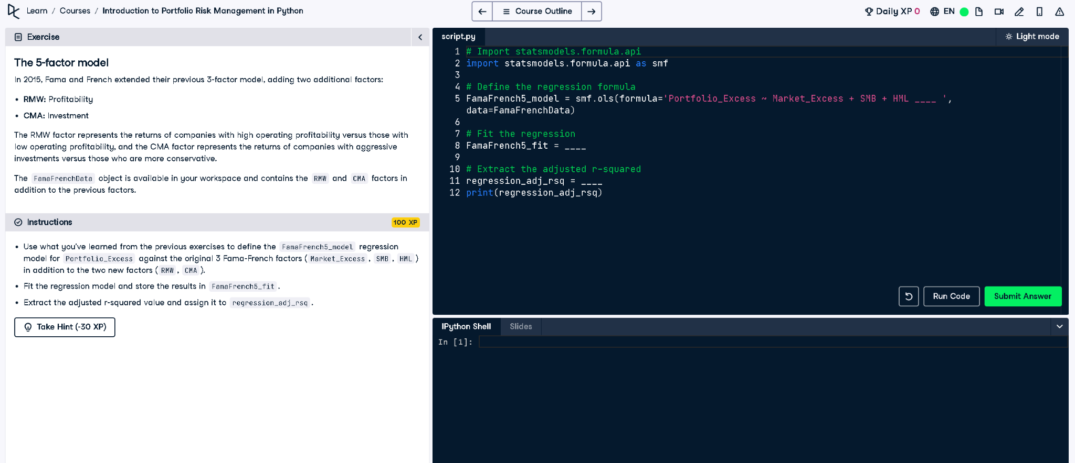

Python Code
# Import statsmodels.formula.api
import statsmodels.formula.api as smf
# Define the regression formula
FamaFrench5_model = smf.ols(formula='Portfolio_Excess ~ Market_Excess + SMB + HML + RMW + CMA',
data=FamaFrenchData)
# Fit the regression
FamaFrench5_fit = FamaFrench5_model.fit()
# Extract the adjusted r-squared
regression_adj_rsq = FamaFrench5_fit.rsquared_adj
print(regression_adj_rsq)

Explanation (Simple Words)
This Python code builds a model using 5 financial factors to explain a portfolio's extra returns. It fits the model with data and gives the adjusted R-squared value, showing how well the model works considering all the factors used.

